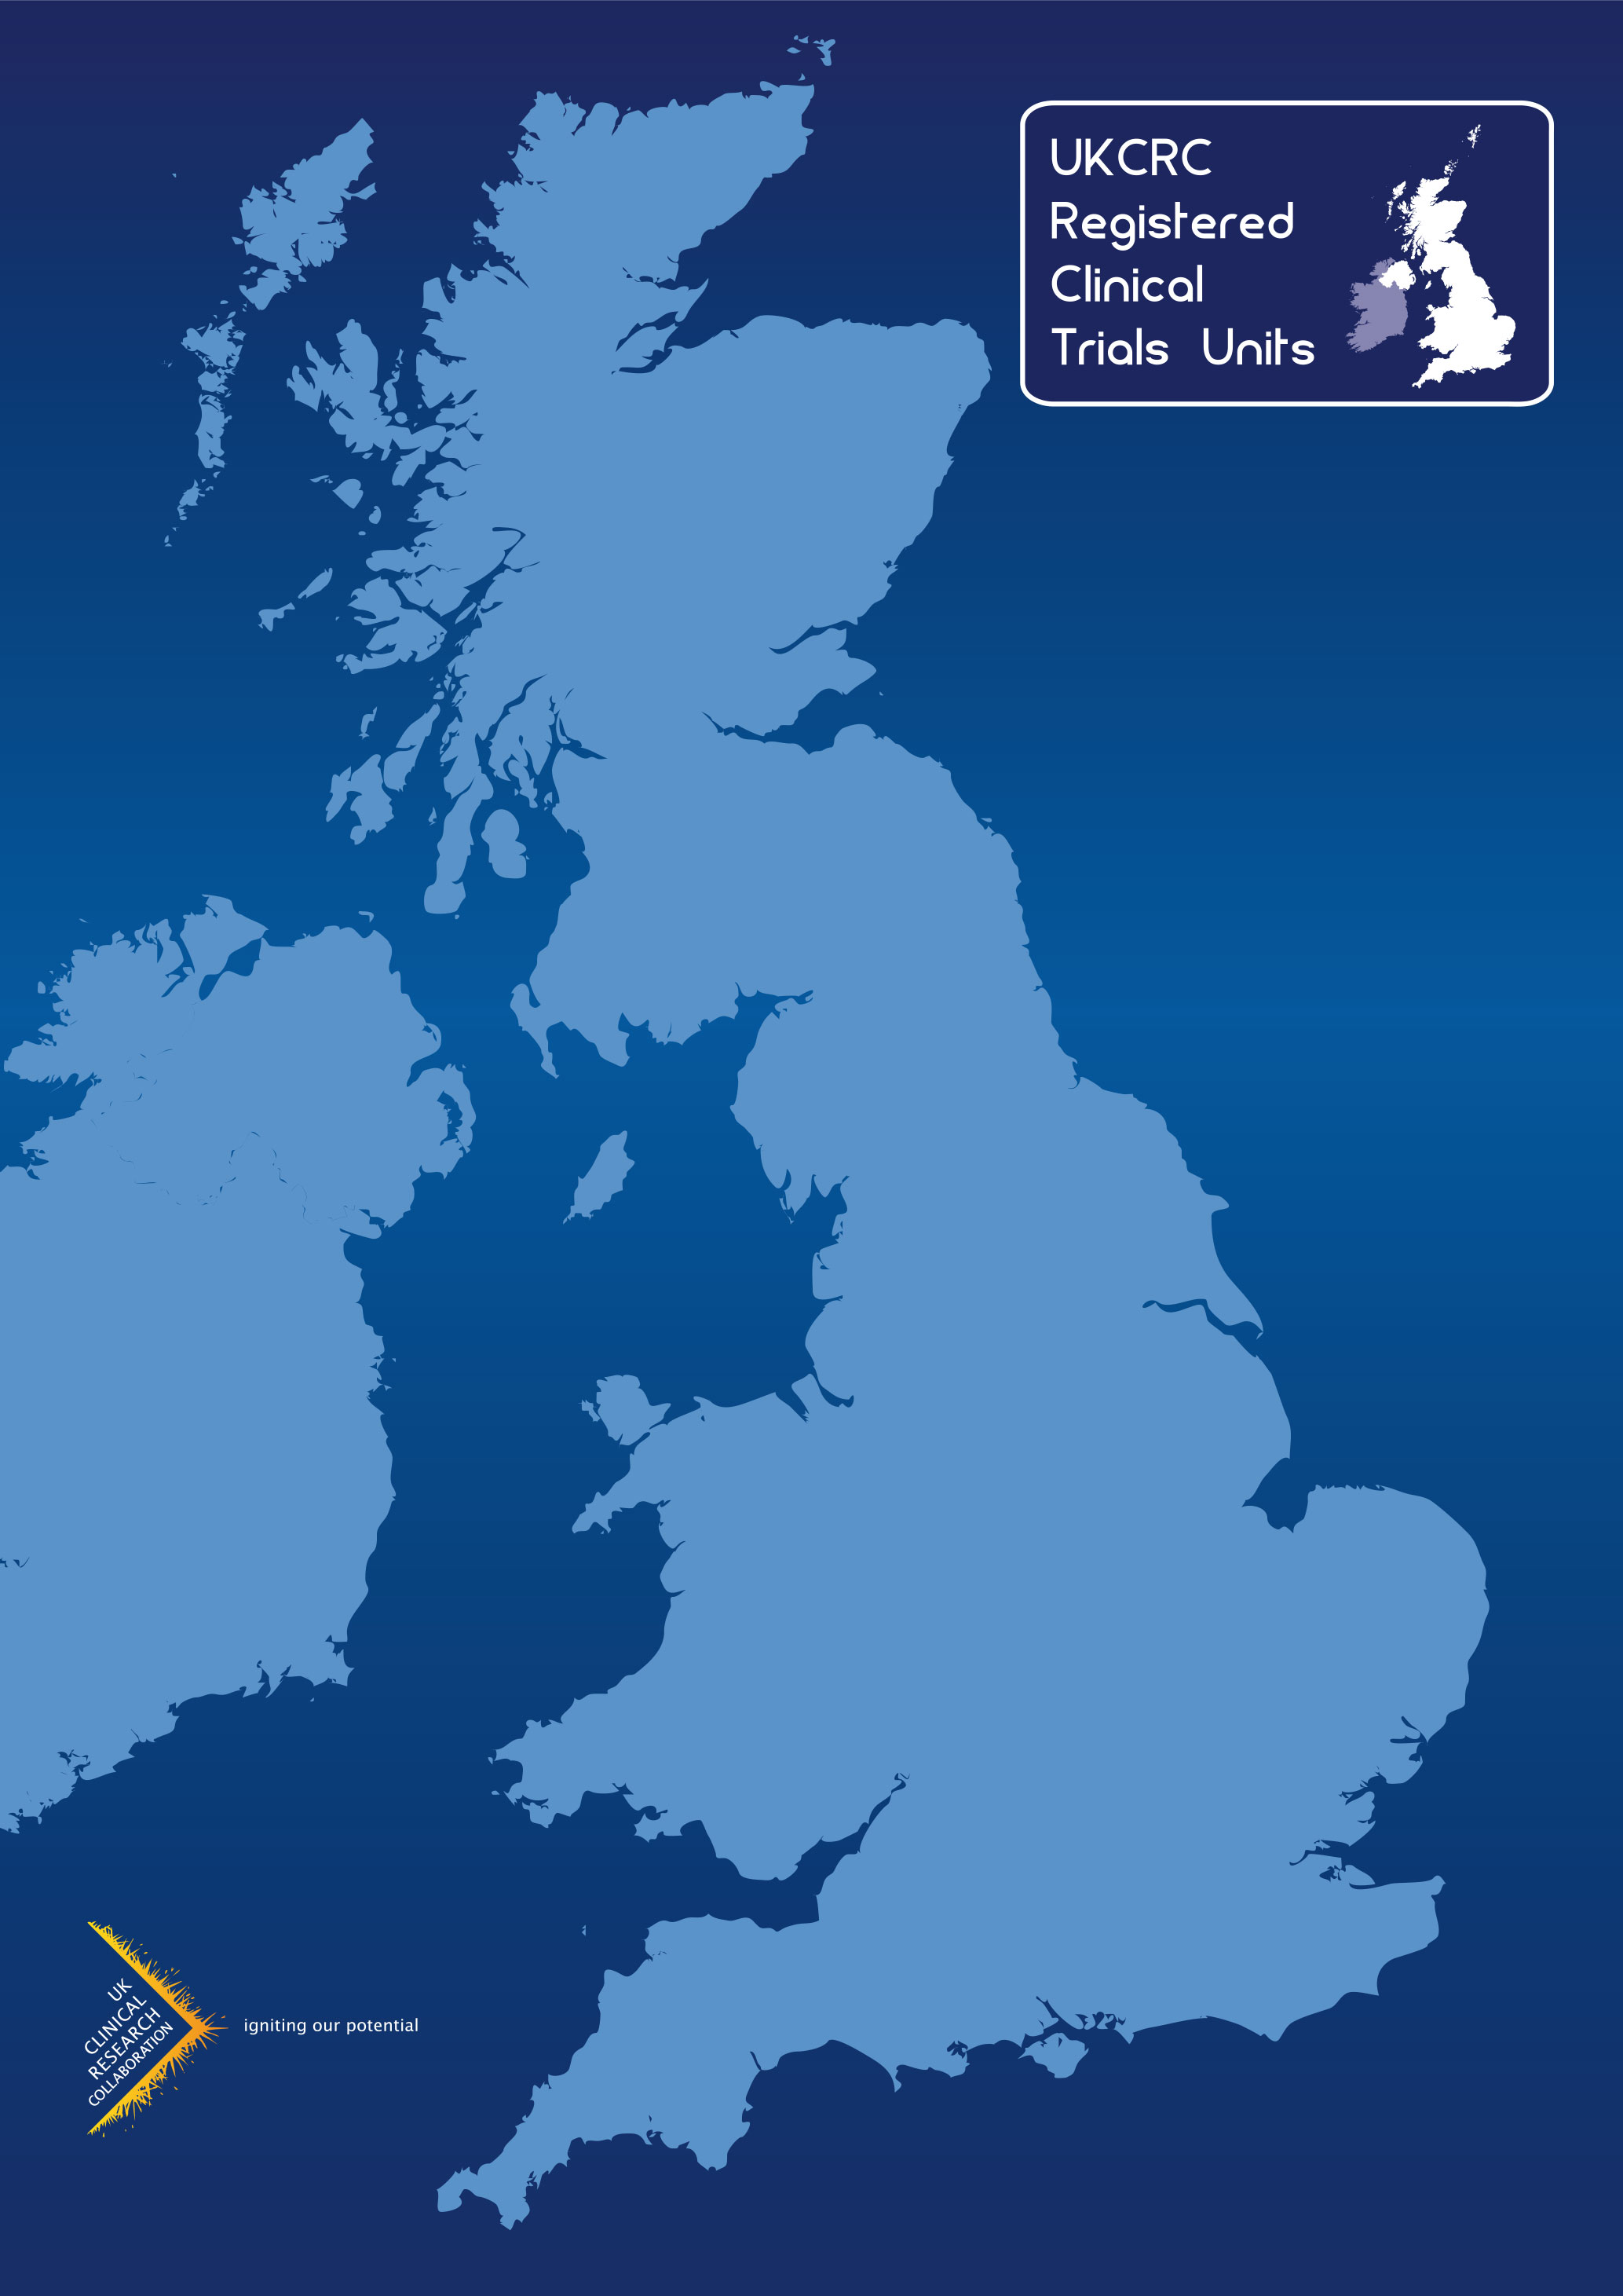

**UKCRC Registered CTU Network –**

**Generic CTU coaching scheme for new clinical trial chief investigators**

**Generic CTU coaching scheme for new clinical trial chief investigators**

*Prepared by the UKCRC Registered Trials Units Network Chief Investigator Network Group (CING)*

**Editor:**

Rustam Al-Shahi Salman (Chair) – Edinburgh Clinical Trials Unit

**Authors:**

Rustam Al-Shahi Salman (CING chair) – Edinburgh Clinical Trials Unit

Anna Kirby (CING member) – The Institute of Cancer Research Clinical Trials & Statistics Unit

Gareth Griffiths (Chair of the Cancer Research UK CI training and support Working Group) – Southampton Clinical Trials Unit

Tom Hellyer (CING deputy chair) – Newcastle Clinical Trials Unit

Ceri Battle (CING member) – Swansea Trials Unit

**Other contributors:**

Amy Ahern – Cambridge Epidemiology & Trials Unit

Ashwin Dhanda – Peninsula Clinical Trials Unit

Gareth Griffiths – Southampton Clinical Trials Unit

Katie Morris – Birmingham Clinical Trials Unit

David Russell – Leeds Clinical Trials Research Unit

Rona Smith – Cambridge Clinical Trials Unit

Table of Contents

1. Abbreviations 4

2. Executive summary 5

3. The need for mentoring, coaching and peer support for chief investigators of clinical trials 5

3.1. Who are chief investigators? 5

3.2. Why do chief investigators need coaching? 5

4. What mentorship, peer support, or coaching opportunities are available for chief investigators of clinical trials in the UK? 6

4.1. The Academy of Medical Sciences 6

4.2. Funding agencies 6

4.3. Survey of the UKCRC CTU network 7

4.4. Successful aspects of coaching schemes 8

5. Generic coaching scheme for new clinical trial chief investigators 8

5.1. Aim 8

5.2. Competencies 9

5.3. Eligibility of new CIs 9

5.4. Eligibility of coaches 9

5.5. Identification and initiation 9

5.6. Roles and responsibilities of the people involved 10

5.7. Suggested structure of a coaching session 10

5.8. Frequency of coaching sessions 10

5.9. What if problems occur? 11

6. Requirements and allocated resources 11

7. Evaluation 11

8. References 12

Appendix 1 - Examples of coaching relationship responsibilities 14

# Abbreviations

CI – Chief Investigator

CING – Chief Investigator Network Group

CTU – Clinical Trials Unit

UKCRC – UK Clinical Research Collaboration

# Executive summary

This document sets out a framework and the key principles for coaching for ‘new’ (i.e. first-time) chief investigators (CIs) of clinical trials conducted with clinical trials units (CTUs) in the UKCRC Network of registered CTUs. This coaching scheme could be delivered by one CTU, or a group of CTUs. This scheme can supplement training opportunities such as the UKCRC CTU Network’s How To Be A Great Chief Investigator of Clinical Trials course, an ongoing ‘Associate CI scheme’ initiative to create earlier training and development pathways for CIs of the future, and local or nationwide mentoring or peer support schemes. This document describes the need for new CI coaching, the structure and function of a generic CTU-delivered coaching scheme for new CIs, the resources required, and the importance of evaluation. This document can be adapted by registered CTUs in the UKCRC Network according to their local composition, capacity, institutional support available, and extent of experienced CI involvement in the CTU. Feedback is welcome!

*Rustam Al-Shahi Salman, UKCRC CTU Network clinical director*

*7 October 2025*

# The need for mentoring, coaching and peer support for chief investigators of clinical trials

## Who are chief investigators?

David Sackett’s Clinician-Trialist Rounds in the journal *Clinical Trials* recognised the need for specific support for chief investigators (CIs) of clinical trials,[1] who may be a healthcare professional, trial methodologist, or related discipline.[2] CIs have challenging and extensive responsibilities in the leadership of clinical trials,[3] without a formal requirement for education, training or experience in collaborating with specialists in the design and delivery of clinical trials.

## Why do chief investigators need coaching?

The clinical trial pathway is extremely complex, includes many different professionals, and is highly regulated with extensive responsibilities (including a legal framework in which a Sponsor delegates responsibilities to a CI). Despite the availability of training resources relevant to clinical trials, their unique challenges may be unfamiliar and overwhelming for new (i.e. first-time) CIs of clinical trials working with a Clinical Trials Unit (CTU). Coaching, mentoring, and peer support may all help.

For CIs of clinical trials specifically, there do not seem to be any specific mentoring, coaching, or peer support programmes. However David Sackett initiated a series of 28 ‘Clinician-Trialist Rounds’ in 2010,1 which drew on experience to offer advice about generic issues for CIs like time management,1 2 priority setting,3 grant funding,4 5 and saying no,6-8 as well as issues specific to clinical trial design and conduct.9-16 Six articles dealt with the need for mentoring,17 the structure and function of effective mentoring,18 19 the attributes of an effective mentor,20 and the problems that can arise between mentor and mentee.21 22 One article dealt with apprenticeships for CIs in training.23 Two articles covered graduate courses in clinical trials.24 25

**What is coaching?**

Coaching unlocks someone’s potential to maximise their performance, helping them learn, rather than teaching them.

**What is mentoring?**

Mentoring is a developmental dialogue between two people who meet as equals. It is a process of ongoing support and development, which can empower the mentee to tackle issues and problems that they identify.

**What is peer support?**

Peer support is a process in which people who share similar environments/experiences or are facing similar challenges come together as equals to give and receive assistance based on the knowledge gained from shared experience.

Several attributes of these professional relationships (trust, questions, review, respect, support, listening, and reflections) are common to both mentoring and coaching. Specifically, coaching could be helpful for new CIs of clinical trials, if an experienced coach conveys skills, competencies, knowledge, and behaviours to optimise the collaboration between a less experienced colleague and a CTU,26 successfully cultivating a culture of mutual respect and understanding expectations.

# What mentorship, peer support, or coaching opportunities are available for chief investigators of clinical trials in the UK?

A variety of schemes are available in the UK. Some are restricted to England, or devolved nations, so the following are some examples at the time of writing.

## The Academy of Medical Sciences

This flagship one-to-one mentoring [programme](https://acmedsci.ac.uk/grants-and-schemes/mentoring-and-other-schemes/mentoring-programme) has run for 20 years for any post-doctoral or independent biomedical or health researcher with career development support, enabling them to select a mentor outside their institution using online mentoring profiles.

## Funding agencies

Some funding agencies (e.g. the National Institute for Health and Care Research [NIHR] and Cancer Research UK [CRUK]) have created dedicated fellowships or opportunities for joint lead applicants in clinical trial funding applications. CRUK offers a [Clinical Trial Fellowship Award](https://www.cancerresearchuk.org/funding-for-researchers/our-funding-schemes/clinical-trial-fellowship-award), which is designed to support clinicians with a demonstrable interest in clinical trials and who would benefit from further training within the setting of a CTU in order to gain clinical trial experience, with the ultimate objective of leading high impact, practice changing cancer clinical trials in the future as a CI. The CRUK clinical trial fellowship requires a joint lead applicant, a mentor, and a main supervisor (who might take the role of a coach). Furthermore, there is a CRUK CI training and support working group which develops e-learning and courses for new CIs, but these provide orientation (e.g. [roadmap to developing a trial with a clinical trials unit](https://features.cancerresearchuk.org/clinicalinvestigatorroadmap/)) or guidance (e.g. [partnering with an oncology trials unit](https://www.cancerresearchuk.org/sites/default/files/partnering_with_a_clinical_trials_unit.pdf)), and do not involve coaching. The [NIHR Postdoctoral Awards](https://www.nihr.ac.uk/career-development/research-career-funding-programmes/postdoctoral/postdoctoral-award) include Advanced Fellowships suitable for new CIs of clinical trials; furthermore, the NIHR funding streams for clinical trials permit the addition of a joint lead applicant, which can be used to enable a new CI to be supported by a more experienced clinical trialist as a mentor or coach.

## Survey of the UKCRC CTU network

Some CTUs also provide support for CIs. In a survey of the Directors of 52 CTUs in the UKCRC registered Network on 15 March 2022, 28 (54%) responded. Only four (14%) CTUs reported having mentorship programmes, all of which were optional; two offered mentoring, one used a Clinical Trial Management module, one delivered coaching, and none organised peer support. One of the CTUs apparently used on-site training in addition to mentoring. However, none of these programmes had been evaluated to determine their efficacy. Representatives of 17 (68%) of the CTUs without CI development programmes indicated that they would be interested in setting up such a scheme. Key observations by the CTUs about the needs of CIs and barriers to setting up development programmes are illustrated in the histograms below:

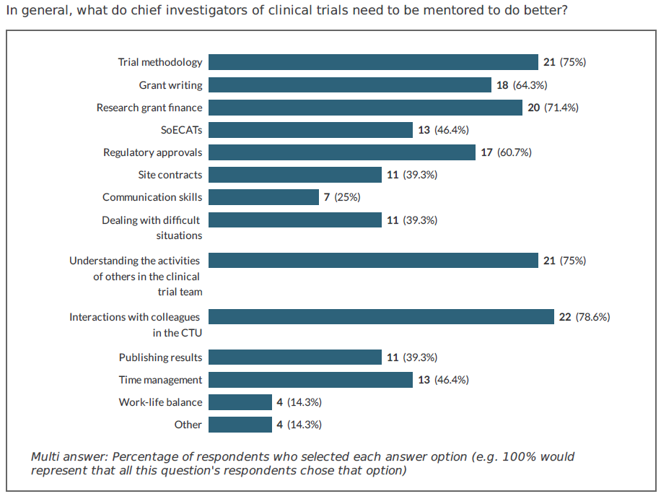

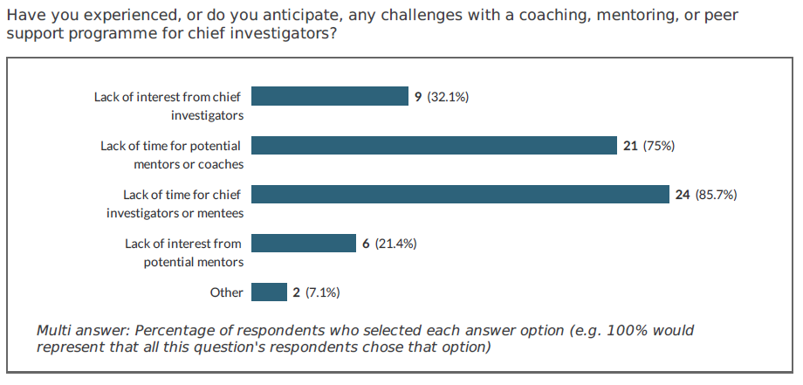

## Successful aspects of coaching schemes

Combining what has been learned from successful mentoring and coaching schemes, David Sackett’s advice in his Clinician-Trialist Rounds, and experiences of CI coaching at four CTUs, the key elements that seem to have determined the success of such programmes are:

* People
  + Commitment from mentor, mentee, and their institutions
  + Mentees choosing their own mentors27
  + Interpersonal skills of mentors
  + Protected time27
* Organisation
  + Adequate resources27
  + Attention to inequalities
  + Written agreements to define expectations27
  + Clear programme structure
* Design
  + Resources
  + Plans/checklists
  + Milestones with timelines
  + Flexible timing and modality of delivery
* Evaluation with metrics

# Generic coaching scheme for new clinical trial chief investigators

## Aim

This coaching scheme is intended to unlock new CIs’ potential to maximise their performance in collaborating with a CTU and to help them learn about the effective development, design, delivery, and dissemination of clinical trials. It is not a mentoring or training programme.

## Competencies

The competencies in which new CIs could be expected to grow with coaching support include:

1. An understanding of the structure and function of the CTU.
2. Optimal approaches to collaborating with a diverse range of CTU professionals, so that ‘team science’ effectively designs and delivers a trial.
3. The importance of rigorous trial methodology, PPIE, and research inclusion in the design of clinical trials.
4. Leading on a clinical trial grant application.
5. Overseeing the budget required for a clinical trial.
6. Regulatory approval requirements.
7. Effective leadership, communication, collaboration, time management and delivery of a clinical trial in collaboration with a CTU.
8. Dissemination of clinical trial findings, close-out, and archiving.

## Eligibility of new CIs

People are eligible for the CTU’s coaching scheme if they are:

1. A new CI of a clinical trial (i.e. they haven’t been a CI of a clinical trial before), and
2. They are seeking to obtain, or have obtained funding for this clinical trial, and
3. They will conduct the clinical trial in collaboration with the CTU, and
4. They wish to be coached by an experienced member of the CTU.

## Eligibility of coaches

Coaches are eligible to support new CIs in this coaching scheme if they are:

1. Identified as suitable by the CTU, and
2. They have first-hand experience of working with the CTU as a CI of clinical trials, and
3. They are not already based in the same research group / department as the new CI, and
4. They have the time and support available to fulfil their responsibilities as a coach (see below).

## Identification and initiation

* A new CI should be identified when they seek support from the CTU for a funding application for a clinical trial, at which time the CTU might direct the new CI to their new CI coaching scheme (e.g. document or webpage).
* If the CTU agrees to support the new CI’s funding application and the new CI accepts the offer of a coach, the CTU will connect the new CI with someone who oversees the coaching programme, who will meet the new CI.
* The new CI will be given the opportunity to identify potential coaches (meeting the criteria in section 5.4 above) and express their order of preference (if any). The CTU clinical director or equivalent should ensure that due consideration is given to aspects of diversity and inclusivity that might have a bearing on the coaching relationship.
* Once a coach is identified, the CTU will connect the coach and the new CI.
* The coach will set up the first meeting with the new CI and discuss and agrees the frequency of future meetings.
* Thereafter, the new CI should take the lead in organising meetings.
* The coach could be engaged in the following activities with the new CI:
  + during bid development for the clinical trial,
  + included as a co-applicant (to recognise their time commitment to coaching and other contributions during the trial),
  + invited to planning meetings during the start-up phase (retaining awareness from agendas and minutes may be sufficient to monitor progress), and
  + invited to the Trial Management Group meetings for awareness of trial progress and any issues arising (retaining awareness from agendas and minutes may be sufficient).

## Roles and responsibilities of the people involved

Commitment to the coaching relationship is required from the new CI, the coach and the CTU. An example of the roles and responsibilities of a new CI, coach, and CTU are provided in section 9.

## Suggested structure of a coaching session

Structure underpins time-effective coaching, and the following recommended structure may be helpful19 for a coaching session between the coach and new CI, although flexibility and adaptation to the specific needs of the new CI should be encouraged:

* Greet and check in
* Confirm that the new CI will take minutes focussed on key decisions/actions
* Celebrate any good news
* Identify any urgent issues for the top of the agenda
* Set an agenda
* Review any items pending from the last session
* Assess the time available for the session
* Prioritise the agenda items and get started
* Summarise actions (using the SMART approach) and clarify responsibilities
* Set the date of the next meeting
* The new CI emails minutes immediately after the meeting

## 

## Frequency of coaching sessions

Meetings should occur at a mutually agreed frequency, which may reduce after the early stages of bid development, trial start-up, and trial set-up phases of the project. Flexibility is to be encouraged to accommodate the needs of the new CI, so impromptu / ad hoc check-ins may be required, and adapt to the time that that both new CI and coach have available. The coaching relationship is expected to last the duration of a clinical trial and adapt to the major milestones of a clinical trial:

* Application development, internal peer review, costing, and submission timeline
* Start-up planning
* Set-up and regulatory approvals
* Recruitment
* Follow-up
* Analysis
* Dissemination

## What if problems occur?

* The problem that is most likely to arise is a lack of time for either the coach, the new CI, or both. This was the main challenge identified by the respondents to a survey of UKCRC CTUs. Hopefully, this would manifest as a cancellation with warning, but a no-show might happen, and advice on how to handle this is available.22
* Failure to complete tasks and meetings grinding to a halt can be prevented and resolved.22
* Abuses of power are concerning, and should be escalated.21
* Although the coaches who are drawn from the CTU are chosen for their collaborative nature, unanticipated difficulties due to interpersonal differences with the new CI may arise.
* The coach may leave the CTU’s institution, in which case the CTU clinical director or equivalent will confirm the need for a successor with the new CI and identify a successor in the same way that the preceding coach was identified, as described above.

If any of these problems are identified by either party, they should try to resolve the issue, but if it cannot be resolved they can raise this with the CTU clinical director or equivalent who will seek to resolve the problem with mutual consent and only escalate if this fails.

# Requirements and allocated resources

The Academy of Medical Sciences recognises that there are three key components to a good mentoring scheme, which also apply to coaching and peer support:

1. Infrastructure and resources (including communications channels and materials)
2. Leadership and commitment (including a committed organisation, senior leader advocate, and a protected budget)
3. People and support (including clear ownership, dedicated staff, and support for both parties in the relationship)

CTU administrative support, a clinical director and a clinical advisory group are useful support for a CTU coaching scheme and its evaluation.

# Evaluation

The CTU coaching scheme should be evaluated regularly, for example annually. A short questionnaire could be used to assess satisfaction, successes, challenges, and comments from coaches and the new CIs. The evaluation should be provided for the CTU Director and clinical director or equivalent.

# References

1. Sackett DL. Clinician-trialist rounds: 1. Inauguration, and an introduction to time-management for survival. *Clin Trials* 2010;7(6):749-51. doi: 10.1177/1740774510385776 [published Online First: 2010/12/09]

2. Sackett DL. Clinician-trialist rounds: 2. time-management of your clinical practice and teaching. Clin Trials 2011;8(1):112-4. doi: 10.1177/1740774510392393 [published Online First: 2011/02/22]

3. Sackett DL. Clinician-trialist rounds: 3. Priority setting for academic success. Clin Trials 2011;8(2):235-7. doi: 10.1177/1740774510396934 [published Online First: 2011/04/12]

4. Szatmari P, Sackett DL. Clinician-trialist rounds: 11. When your grant gets turned down--part 1: remorse, anger, and reconciliation. Clin Trials 2012;9(4):447-9. doi: 10.1177/1740774512449701 [published Online First: 2012/08/28]

5. Szatmari P, Sackett DL. Clinician-trialist rounds: 12. When your grant gets turned down--part 2: resurrection. Clin Trials 2012;9(5):660-3. doi: 10.1177/1740774512455465 [published Online First: 2012/10/13]

6. Oxman AD, Sackett DL. Clinician-trialist rounds: 14. ways to advance your career by saying 'no' - part 2: when to say 'no', and why. Clin Trials 2013;10(1):181-7. doi: 10.1177/1740774512467238 [published Online First: 2013/01/25]

7. Oxman AD, Sackett DL. Clinician-trialist rounds: 15. Ways to advance your career by saying 'no'--part 3: how to say 'no', nicely. Clin Trials 2013;10(2):340-3. doi: 10.1177/1740774513477934 [published Online First: 2013/03/30]

8. Oxman AD, Sackett DL. Clinician-trialist rounds: 13. Ways to advance your career by saying 'no' - part 1: why to say 'no' (nicely), and saying 'no' to email. Clin Trials 2012;9(6):806-8. doi: 10.1177/1740774512463177 [published Online First: 2012/12/20]

9. Sackett DL. Clinician-trialist rounds: 4. why not do an N-of-1 RCT? Clin Trials 2011;8(3):350-2. doi: 10.1177/1740774511404718 [published Online First: 2011/07/07]

10. Sackett DL. Clinician-trialist rounds: 5. Cointervention bias--how to diagnose it in their trial and prevent it in yours. Clin Trials 2011;8(4):440-2. doi: 10.1177/1740774511410995 [published Online First: 2011/08/13]

11. Sackett DL. Clinician-trialist rounds: 6. Testing for blindness at the end of your trial is a mug's game. Clin Trials 2011;8(5):674-6. doi: 10.1177/1740774511419685 [published Online First: 2011/10/21]

12. Pogue J, Sackett DL. Clinician-trialist rounds: 19. Faux pas or fraud? Identifying centers that have fabricated their data in your multi-center trial. Clin Trials 2014;11(1):128-30. doi: 10.1177/1740774513503524 [published Online First: 2013/10/08]

13. Sackett DL. Clinician-trialist rounds: 16. Mind your explanatory and pragmatic attitudes! - part 1: what? Clin Trials 2013;10(3):495-8. doi: 10.1177/1740774513484395 [published Online First: 2013/05/22]

14. Sackett DL. Clinician-trialist rounds: 17. Mind your explanatory and pragmatic attitudes! Part 2: How? Clin Trials 2013;10(4):633-6. doi: 10.1177/1740774513491339 [published Online First: 2013/06/25]

15. Sackett DL. Clinician-trialist rounds: 18. Should young (and old!) clinician-trialists perform single-arm Phase II futility trials? Clin Trials 2013;10(6):987-9. doi: 10.1177/1740774513503523 [published Online First: 2013/10/03]

16. Pogue J, Sackett DL. Clinician-trialist rounds: 23. When an RCT's Data Center Report drowns vital information in seas of data: where's Waldo? Clin Trials 2014;11(5):601-4. doi: 10.1177/1740774514534347 [published Online First: 2014/06/25]

17. Straus SE, Sackett DL. Clinician-trialist rounds: 7. Mentoring: why every clinician-trialist needs to get mentored. Clin Trials 2011;8(6):765-7. doi: 10.1177/1740774511423948 [published Online First: 2011/12/15]

18. Straus SE, Sackett DL. Clinician-trialist rounds: 8. Mentoring - part 2: the structure and function of effective mentoring linkage, resources, and academic opportunities. Clin Trials 2012;9(1):128-31. doi: 10.1177/1740774511430241 [published Online First: 2012/02/16]

19. Straus SE, Sackett DL. Clinician-trialist rounds: 9. Mentoring - part 3: the structure and function of effective mentoring: advice and protection. Clin Trials 2012;9(2):272-4. doi: 10.1177/1740774512436615 [published Online First: 2012/04/13]

20. Straus SE, Sackett DL. Clinician-trialist rounds: 10. Mentoring - part 4: attributes of an effective mentor. Clin Trials 2012;9(3):367-9. doi: 10.1177/1740774512440343 [published Online First: 2012/06/14]

21. Straus SE, Sackett DL. Clinician-trialist rounds: 22. The presenting complaints, diagnoses, and treatments of mentorships in trouble. Part 2: abuses of power. Clin Trials 2014;11(4):508-11. doi: 10.1177/1740774514527652 [published Online First: 2014/04/09]

22. Sackett DL. Clinician-trialist rounds: 21. The presenting complaints, diagnoses and treatments of mentorships in trouble. Part 1: Dysfunctional mentorship meetings. Clin Trials 2014;11(3):376-79. doi: 10.1177/1740774513519877 [published Online First: 2014/02/25]

23. Sackett DL. Clinician-trialist rounds: 20. Shouldn't 'trialists-in-training' rotate through RCT-clerkships? Clin Trials 2014;11(2):263-6. doi: 10.1177/1740774513511716 [published Online First: 2013/12/11]

24. Norman GR, Sackett DL. Clinician-trialist rounds: 25. Designing an evidence-based introductory graduate course in clinical trials. Part 2: Applying the evidence to your RCT course design. Clin Trials 2015;12(1):91-3. doi: 10.1177/1740774514552111 [published Online First: 2014/10/04]

25. Norman GR, Sackett DL. Clinician-trialist rounds: 24. Modernizing your introductory graduate course in clinical trials. Part 1: Commonsense meets evidence. Clin Trials 2014;11(6):681-4. doi: 10.1177/1740774514542622 [published Online First: 2014/07/18]

26. McKinney CM, Mookherjee S, Fihn SD, Gallagher TH. An Academic Research Coach: An Innovative Approach to Increasing Scholarly Productivity in Medicine. J Hosp Med 2019;14(8):457-61. doi: 10.12788/jhm.3194 [published Online First: 20190408]

27. Kashiwagi DT, Varkey P, Cook DA. Mentoring programs for physicians in academic medicine: a systematic review. Acad Med 2013;88(7):1029-37. doi: 10.1097/ACM.0b013e318294f368 [published Online First: 2013/05/25]

# Appendix 1 - Examples of coaching relationship responsibilities

#### Clinical Trials Unit

* Agree to the recommendations in this document.
* Ensure awareness of the scheme and its principles amongst CTU staff.
* Recommend the scheme to new CIs who qualify for the scheme.
* Ensure that adequate support to administer the scheme is provided by the CTU or its host institution(s).

#### New **Chief Investigator**

* Agree to the recommendations in this document.
* Ensure that adequate protected time is available for coaching.
* Identify and discuss their preferred coach(es) with the CTU clinical director or equivalent, raising any issues that are relevant to equality, diversity and inclusion.
* Read CTU guidance for CIs.
* Identify their clinical trial-specific development needs.
* Organise, agree format (virtual/face-to-face), attend, and document meetings with the coach.
* Cancel meetings with adequate notice.
* Defer to the CTU clinical director, Director, or Chief Operating Officer if required.

### 

#### Coach

* Agree to uphold the recommendations in this document.
* Ensure that adequate protected time is available for coaching.
* Embody the suitable personal attributes and behaviours that characterise an effective mentor/coach.20
* Attend to equality, diversity and inclusion throughout.
* Agree format (virtual/face-to-face) and attend meetings with the new CI.
* Cancel meetings with adequate notice.
* Read the agendas and minutes of the new chief investigator’s meetings with CTU teams, attending where necessary, to retain awareness of trial progress and any issues.
* Help the new CI to identify their needs, which may include:
  + Clinical trial-specific knowledge, such as:
    - the local clinical trials strategy
    - how to interact effectively with CTU team members
    - understanding the roles of others in the clinical trial team
    - trial design and methodology, including an embedded study-within-a-trial (SWAT)
    - grant development, grant writing, responses to peer reviewers, resubmission after rejection, checkpoint reviews, negotiations, and extensions
    - patient and public involvement and engagement (PPIE)
    - grant finance including SoECAT
    - budget oversight
    - protocol development
    - oversight committees
    - trial set-up including Sponsor risk assessment and regulatory approvals
    - contracts
    - recruitment
    - retention
    - analysis
    - reporting
    - dissemination
  + Generic issues, which are outside the specific remit of a coach but need intervention with institutional support, such as:
    - communication skills
    - expected behaviours
    - time management
    - project management
    - leadership of a clinical trial with a CTU
* Signpost the new CI to training resources and CTU team leads who can deal with any clinical trial-specific needs.
* Defer to the CTU clinical director, Director, or Chief Operating Officer if required.

1. “The chief investigator is the overall lead researcher for a research project… In addition to their responsibilities if they are members of a research team, chief investigators are responsible for the overall conduct of a research project.” <https://www.hra.nhs.uk/planning-and-improving-research/research-planning/roles-and-responsibilities/#chief>
2. <https://www.hra.nhs.uk/planning-and-improving-research/research-planning/roles-and-responsibilities/mhra-and-hra-position-who-can-act-chief-investigator/>
3. <https://www.hra.nhs.uk/planning-and-improving-research/policies-standards-legislation/uk-policy-framework-health-social-care-research/uk-policy-framework-health-and-social-care-research/#chiefinvestigators>