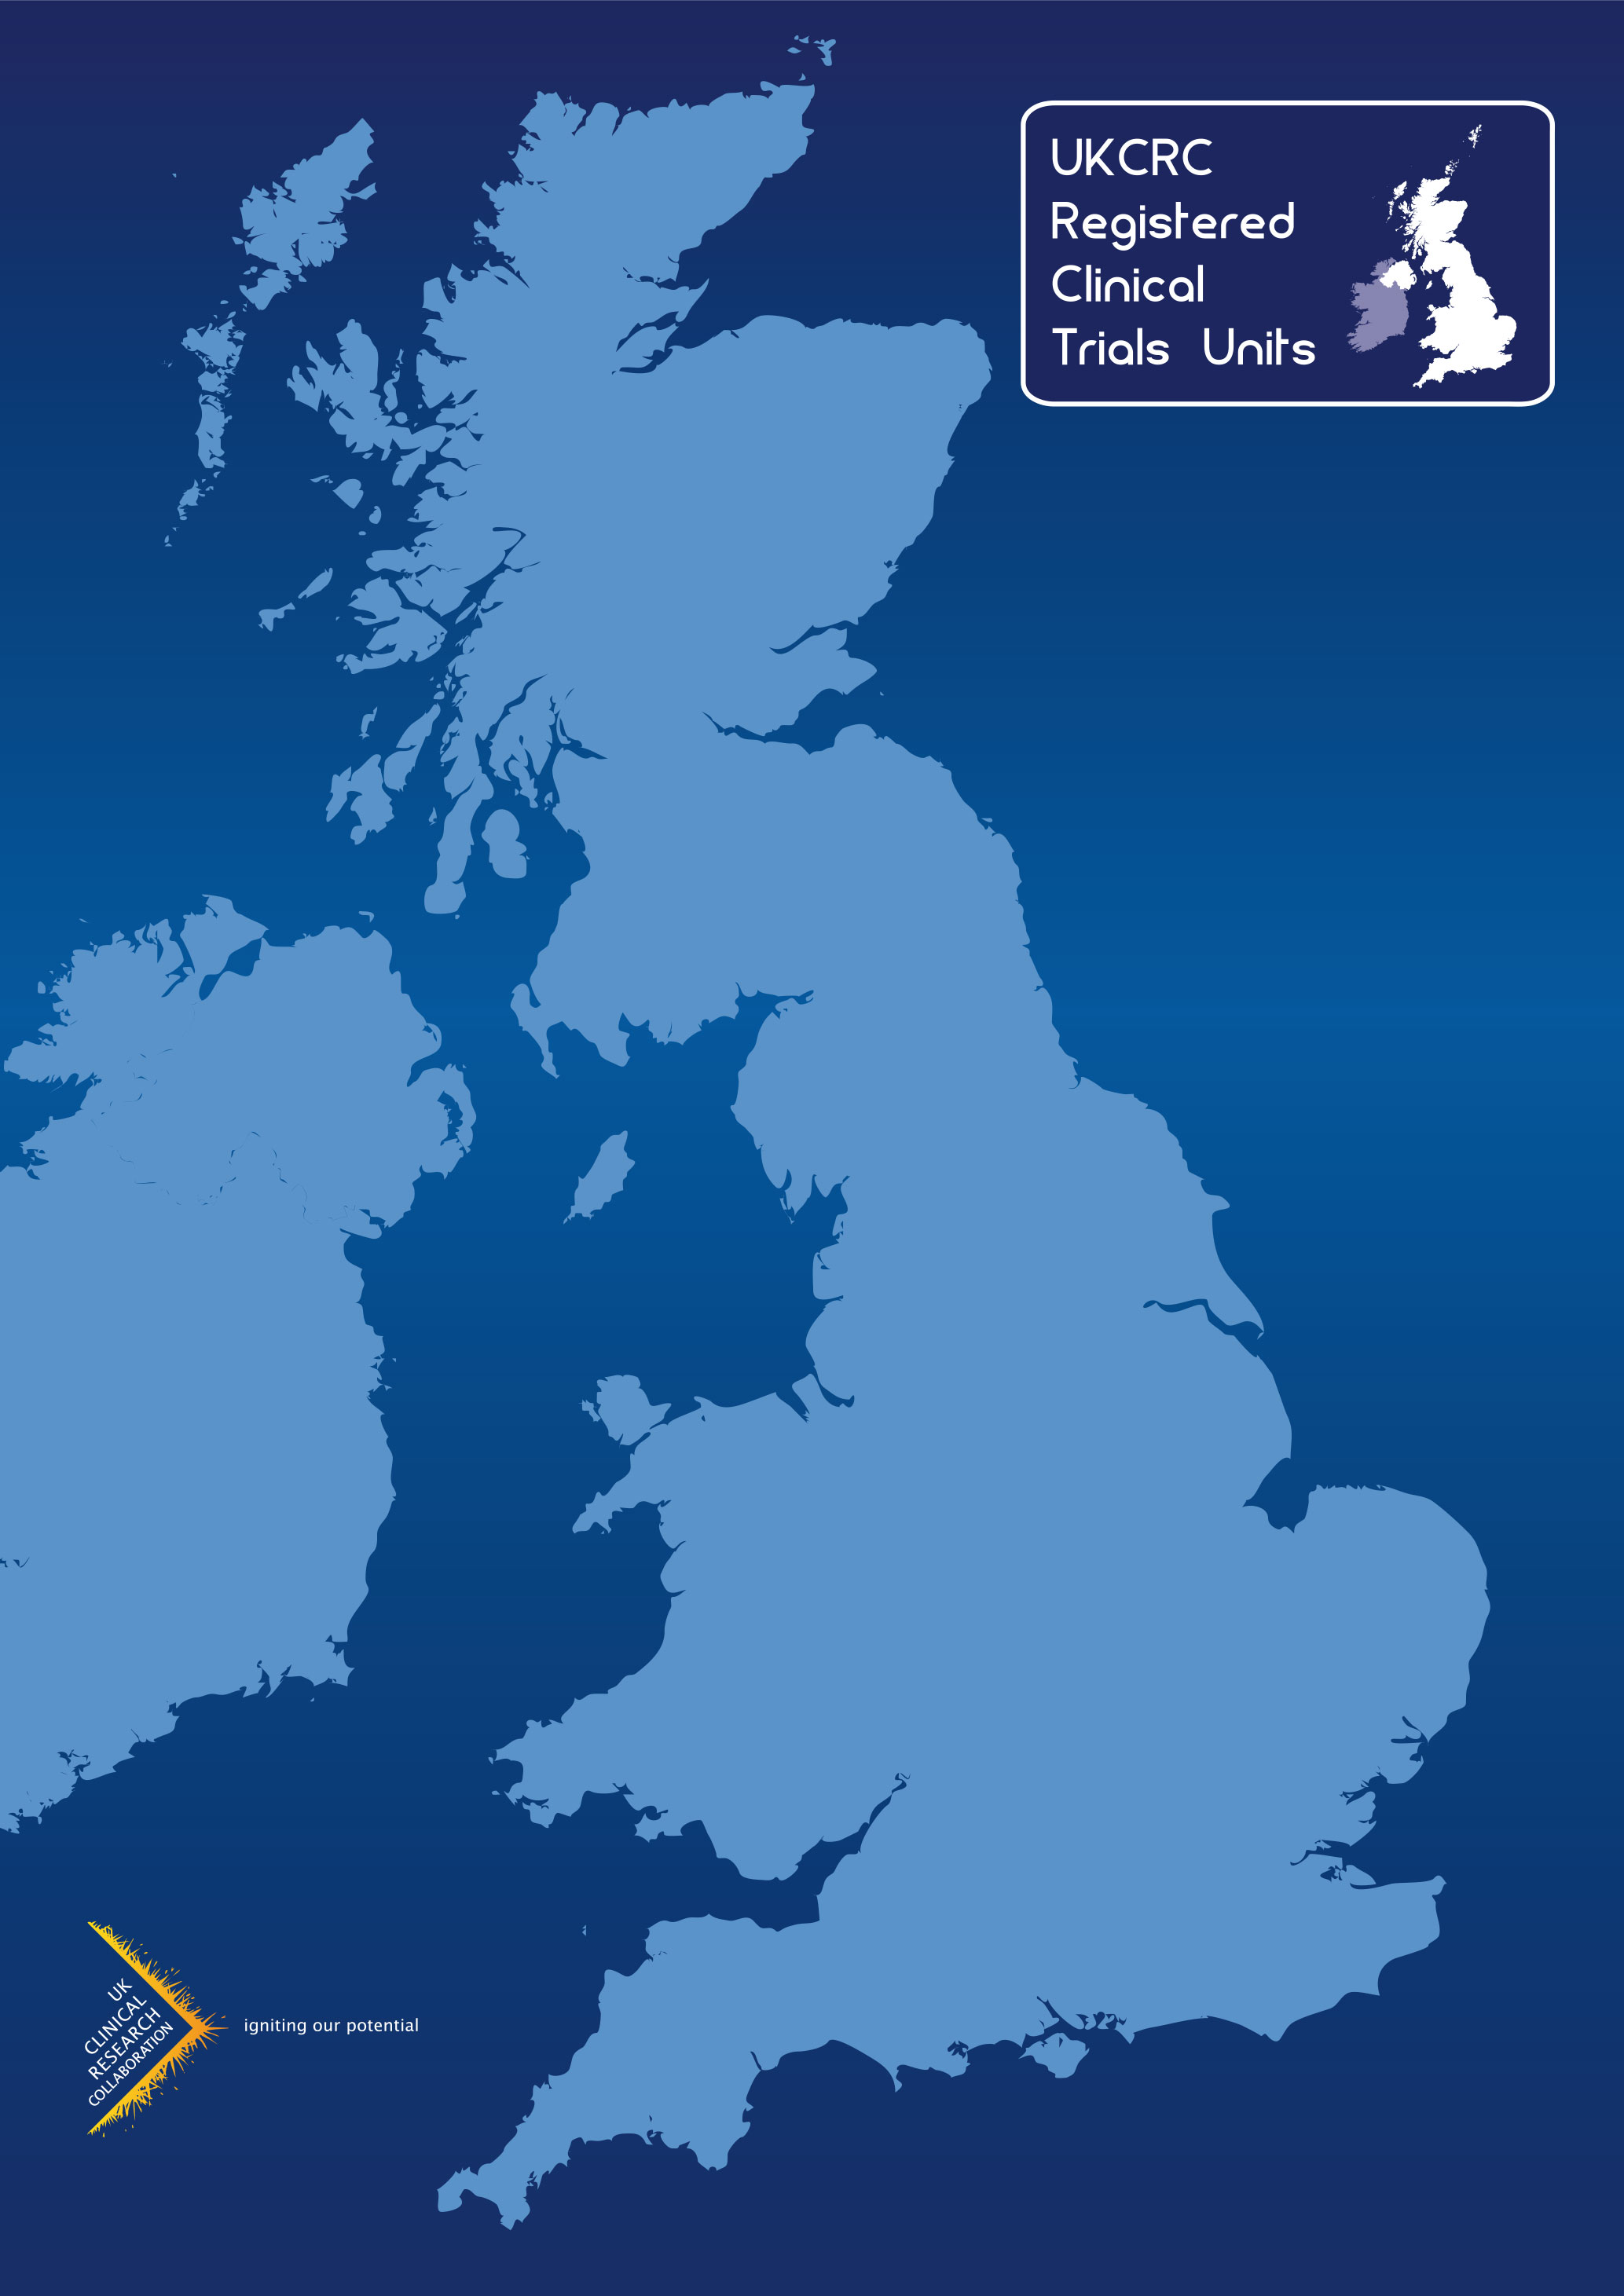
Checklist for Chief Investigator (CI) Engagement

Checklist for Chief Investigator (CI) Engagement Between <<Trials unit name>> and Study Chief Investigator
The Efficient Trial Conduct Group of the UKCRC Registered CTU Network has developed this checklist to support discussions between CIs and Clinical Trials Units (CTUs) covering key areas for consideration when embarking upon a new Clinical Trial Collaboration. This document is for information purposes and should be used as a guide only.
This document is designed to support the relationship between the CI and the CTU and does not replace or substitute the requirement for any formal legal agreements required by the sponsor in accordance with the regulations.
Trial Name: | <<Trial name>>
Chief Investigator: | <<Chief Investigator>>
Sponsor Reference Number: | <<Sponsor reference number>>
<<Trials unit name>> Study Number: | <<Study number>>
Funder reference (if known) | <<Funder reference>>
IRAS Number: | <<IRAS number>>
Please note, this document is not representative of all the Clinical Trials Unit (CTU) and CI responsibilities that will be undertaken during the course of the trial but covers the key areas for delivery. In addition, there are some responsibilities outlined below that may not be applicable depending on the type of trial (e.g. non-CTIMPs).
Abbreviations:
CI Chief Investigator
CTIMP Clinical Trial of Investigational Product
CTU Clinical Trials Unit
DMC Data Monitoring Committee
DSUR Development Safety Update Report
HRA Health Research Agency
IMP Investigational Medicinal Product
IRAS Integrated Research Application System
PM Project Manager
PV Pharmacovigilance
PIS Patient Information Sheet
RA Risk Assessment
REC Research Ethics Committee
RSI Reference Safety Information
SAE Serious Adverse Event
SAP Statistical Analysis Plan
SOP Standard Operating Procedure
SUSAR Suspected Unexpected Serious Adverse Reaction
TMG Trial Management Group
TSC Trial Steering Committee
WI Working Instruction

Role of the Clinical Trials Unit
CTUs are specialist units that have been set up with a specific remit to design, conduct, analyse and publish clinical trials and other well-designed studies. They have the capability to provide specialist expert governance, regulatory, statistical, epidemiological and other methodological advice and coordination to undertake successful clinical trials. <<Trials unit name>> has expertise in the coordination of trials involving investigational medicinal products that must be conducted in compliance with the current UK regulations governing the conduct of clinical trials. CTUs which have been awarded UKCRC Registration were required to provide evidence to an international panel of experts of their capability to centrally coordinate multi-centre clinical trials (i.e. having overall responsibility for the design, development, recruitment, data management, publicity and analysis of a portfolio of trials), and that they had established robust systems to ensure conduct and delivery of clinical trials to the highest quality standards.
Role of <<Trials unit name>> in relation to <<Trial name>>

Guidance notes: Below is a list of examples that may be included in this section. CTUs utilising this template should reviewed and adapt this list in accordance with the requirements of the project. This list is NOT exhaustive and should be amended to reflect CTU and trial
- Development of new trials
- Identification of the right questions and appropriate design
- Systematic reviews (when appropriate)
- Discussions with different disciplines for different trial components e.g. quality of life, health economics, associated translational research
- Development of sub-studies
- Costing the trial and planning the staffing required to develop and manage the trial
- Communication with the Clinical Research Networks regarding feasibility and levels of interest
- Consideration of regulatory and governance issues
- Negotiations with international collaborators, if applicable
- Negotiations with industry, if applicable
- Coordination and preparation of the grant application
- Management of funded trials
- Coordinating protocol development and design of Case Report Forms (CRFs)
- Liaising with potential centres, identifying and initiating participating centres, and maintaining good communication with each centre
- Setting up the trial and obtaining relevant permissions (ethics approval, MHRA approval, etc)
- Recruiting clinical sites in order to identify and recruit eligible trial patients and allocating a trial entry number and treatment to trial patients
- Central coordination and management of essential trial documents and patient data collected from participating clinical sites
- Data monitoring
- Conducting interim and final analyses
- Preparation of reports (e.g. for funding bodies, NRES, MHRA, Data Monitoring Committees, Trial Steering Committees)
- Design and validation of study database
- Study website
- Bespoke IT applications

Role of the Chief Investigator
The named CI takes responsibility for the conduct of the proposed research in the UK. The named CI should normally be a researcher who is professionally based in the UK, so that he/she is able to oversee the research effectively in the UK setting. They MUST be available to communicate with the Research Ethics Committee (REC) and other review bodies during the application process and, where necessary, during the conduct of the research in collaboration with the CTU.
They are also responsible to the funder to deliver the project in accordance with the terms and conditions of the award.
They are responsible for delivering the primary publication of the work in collaboration with the CTU and collaborating investigators.
Guidance note ***reference any internal job descriptions or polices here***
Overall target study timelines
Guidance note: Insert the trial milestone table below if required. If the project has detailed milestones as part of the grant please reference here instead of inserting the table.
Overall Duration: | <<Overall Duration>>
Milestone |  | Target Date
Protocol finalised |  | <<Protocol finalised >>
HRA/Ethics submission |  | <<HRA/Ethics submission>>
MHRA CTA submission (if applicable) |  | <<MHRA CTA submission>>
First site open |  | <<First site open>>
First patient first visit |  | <<First patient first visit>>
Last patient last visit |  | <<Last patient first visit>>
Database locked |  | <<Database locked>>
Publication |  | <<Publication>>

Communication
<<Insert policy of delegation and cover in times of absence or reference the corresponding paragraph in the protocol that covers this>>
Guidance note: Section 1.0 can be ignored if this document is being used post grant award.
SECTION 1.0 Grant Development and Submission
Responsibilities | Timelines
The CTU will:  - Ensure the collaboration process is efficiently managed and allow sufficient time to support the CI in the development of the grant funding application.  - Provide the CI with appropriate support to enable them to submit a complete and competitive grant application including but not limited to, study design, statistical design, project planning, research costs, contacting co-investigators and collaborator and review of the final application.  - Work with local Clinical Research Network (CRN) and NHS partner to determine the Research, service support and excess treatment costs associated with the project.  The CI will:  - Work with the CTU to develop the grant application at all stages (outline/full/single stage) and allow sufficient time for collaborators to make a meaningful academic contribution.  - Provide advice and guidance on the costing model for the study.  - Answering costing queries relating to the patient pathway to ensure proper cost attribution.  - Include Senior CTU staff as co-applicants where appropriate.  - Discuss with the CTU any planned substantial change in the study design/conduct prior to grant submission  - Provide a final copy of the grant submission to CTU. Notify the CTU of the funding decision as soon as possible. | Ideally the CTU should be approached no later than <<number of weeks>> prior to grant deadline
 | Within <<time frame>> of submission

SECTION 2.0 Protocol and Trial Development
Responsibilities | Timelines
2.1. Protocol
The CTU Project Manager (PM) will:  - Provide the CI with an initial draft of the trial protocol (based on CTU Protocol Template document).  - Co-ordinate the multidisciplinary input from a team of experts in the required fields from both within and external to the CTU.  - Ensure the CTU and Sponsor trial team contribute the relevant sections of the protocol to support the CI in the writing of the protocol (e.g. statistics, pharmacovigilance, pharmacy etc.).  - Manage the protocol review process. | Within <<time frame>>  (Guidance note: Insert timelines in relation to your own unit policy indicating when you will start working on a protocol in relation to the funding being available.)
The CI will:  - Work on the initial draft of the clinical trial protocol (using CTU Protocol Template) providing clinical input and expertise.  - Support the review process in order to finalise the clinical trial protocol.  - Ensure the protocol has undergone scientific and statistical review. | Within <<time frame>> of a successful grant  Within <<time frame>> of a successful grant
2. 2 Sponsorship Application
The CTU PM will:  - Ensure the correct sponsorship application process if followed based on local polices.  The CI will:  - Review and confirm the sponsorship application is complete and accurate prior to submission.  - Provide input in to the sponsorship application process as required.  - Ensure all correspondence with sponsor is provided to the CTU. | Within <<time frame>> of a successful grant
2.3. HRA and Regulatory Submissions
The CTU PM will:  - Create and control the IRAS application for the trial.  - Support the CI in the completion of the required regulatory documentation including Patient Information Sheet (PIS) and Informed Consent Form (ICF).  The CI will:  - Support the CTU PM in the completion of all necessary regulatory submissions and ensure these are made within the expected timelines of the grant award.  - The CI must review and approve the PIS and ICF prior to submission for ethical approval. | Within <<time frame>> of finalising the protocol
2.4. Case Report Form (CRF) Design and other data collection tools
The CTU <<role>> will (in liaison with appropriate CTU department):  - Manage the CRF drafting process in parallel with the protocol drafting.  - Create a final version of the CRF using the CTU approved template/process and update this as required during the course of the trial.  - Ensure the completion of a Data Management Plan in line with CTU SOPs.  - Facilitate statistical review of CRFs.  - The CTU Information System team will (in liaison with appropriate CTU department):  - Create a validated study database.  - Create all required IT support systems ensuring they are appropriately validated.  The CI will:  - Provide input, review and approve the CRFs prior to the trial opening, ensuring that all data is captured as detailed in the protocol to answer the trial endpoints.  - Provide clinical input during the CRF drafting process and any amendments required throughout the study. | The final CRF MUST be completed within <<time frame>> of finalising the protocol
2.5. Safety/Pharmacovigilance (PV)
The CTU PM will:  - Liaise with the sponsor, CI and pharmacy with respect to the identification and approval of appropriate Reference Safety Information (RSI) for all Investigational Medicinal Products (IMPs) for the trial (CTIMP ONLY).  - Liaise with sponsor and CI regarding safety reporting requirements including, timeframes, excluded events, coding systems etc.  The CI will:  - Help with the identification of appropriate RSI for all IMPs in preparation for submission to the MHRA (CTIMP ONLY).  - Ensure the risks and side effects listed in the patient information sheet are consistent with the RSI for all IMP(s) (CTIMP ONLY).  - Advice on the Safety Inclusion/exclusions to reporting.  - Identify at least <<number>> medically qualified individuals to review and assess trial safety events. | Within <<time frame>>
2.6. Risk Assessment (RA)
The CTU and the CI are jointly responsible for the trial risk assessment (RA). The RA requires a co-ordinated multidisciplinary approach across the trial team.  The CTU PM will:  - Generate an RA using the CTU template.  - Co-ordinate the input from a team of experts as in the required fields from both within and external to the CTU.  The CI will:  - Provide clinical input into the risk assessment.  - Conduct final review and sign off the RA. | Within <<time frame>>

SECTION 3.0 During the trial
Responsibilities | Timelines
3.1. Protocol
The CTU PM will:  - Prepare all protocol amendment documentation in consultation with the trial team and the sponsor.  - Submit amendment to all the required bodies in a timely manner.  The CI will:  - Ensure all protocol amendments are reviewed and agreed. | Within <<time frame>> of being provided the paperwork
3.2. Statistical Analysis Plan
The CTU Statistician will:  - Write the Statistical Analysis Plan (SAP).  The CI will:  - Review and approve the SAP. | Within <<time frame>>
3.3. Monitoring and Recruitment
The Trial Management Group (TMG), which will include the CI, will:  - Actively oversee recruitment to the trial and where necessary agree/implement strategy where recruitment is not in accordance with initial plan. | Within <<time frame>>
3.4. Reports
The CTU PM will:  - Initiate and prepare report(s) for submission to applicable bodies as laid out in the terms and condition of approval/funding in collaboration with the trial team.  The CI will:  - Contribute to applicable bodies/funder.  - Author sections of reports as directed by the CTU.  - Provide timely review, approval and signature on all reports. | At least <<time frame>> prior to submission deadline  At least <<time frame>> prior to submission deadline
3.5. Safety/Pharmacovigilance (PV)
The CTU PM will: | Guidance note: Insert timeframes here for each activity in line with your unit SOPS for Safety reporting and oversight.
- Send reports/e-mails of all new Serious Adverse Events (SAEs) to the CI for medical oversight. | Within <<time>> of receiving an update
- Communicate information regarding potential Suspected Unexpected Serious Adverse Reactions (SUSARS) /safety events to the CI. | Within <<time>> of receiving an update
- Provide current approved RSI for IMPs to the CI for advice on the clinical management of trial participants and consideration of expectedness. | Within <<time>> of receiving an update
- Ensure updates to source RSI are provide to CI for review and assessment. | Within <<time>> of receiving an update
- Prepare Development Safety Update Reports (DSURs). | Within <<time>> of receiving an update
- Ensure the CTU is in receipt of all required safety alerts from both the MHRA and marketing authorisation holders where appropriate. | Within <<time>> of receiving an update
The CI will:
- With input from the trial statistician and any oversight committees review all new SAEs for the trial on a <<frequency>> in order to ensure CI oversight of safety reporting and if any unexpected, untoward safety issues or unanticipated patterns of SAE reporting are identified, the CI will alert PM immediately. | Within <<time>> of receiving an update
- Review of SAES for causality and expectedness. | Within <<time>> of receiving an update
- Answer safety related queries and identify SUSARs. | Within <<time>> of receiving an update
- Review safety alerts. | Within <<time>> of receiving an update
- Literature review ensuring the team are aware of the relevant clinical developments and safety information. | Within <<time>> of receiving an update
- Give a clinical opinion on any changes to the trial risk-benefit assessment and the clinical management of patients following the update of RSI and completion of the DSUR for IMPs and advise of any changes required to the PIS, management of the trial and protocol. | Within <<time>> of receiving an update
- Complete RSI review on receipt of update. | Within <<time>> of receiving an update

SECTION 4.0 End of Trial
Responsibilities | Timelines
4.1 End of Study Reports
The writing, approval and distribution of the end of Study report is a team responsibility and although the trials unit can facilitate the activity it needs input from all parties.  The CTU PM will:  - Co-ordinate the writing of End of Study report(s) for submission to applicable bodies liaising with all collaborators and investigators as appropriate.  - Prepare and submit end of trial notification to applicable bodies.  - Upload results to EudraCT.  The CI will:  - Author sections of the End of Study report as directed by the CTU PM.  - Edit, review, approve, and sign off end of trial reports. | Within <<time>> of end of trial
4.2 Publication of Final Study Manuscript
The CTU will:  - Assist in the manuscript preparation as directed by the CI.  - Help to identify the target journal(s) for publication if required (Study Statistician).  - Provide a final statistical report and statistical input into the manuscript in line with the Statistical Analysis Plan (SAP).  The CI will:  - Initiate and lead on the preparation of the final study manuscript process.  - Identify the target journal(s) for publication.  - Review and approve the final statistical report.  - Identify who will be involved in the writing up of the final study manuscript.  - Produce the final study manuscript (ready for submission). | Within <<time>> of the End of trial declaration being submitted
Please note:
The Trial Management group, CTU and Sponsor will monitor progress on manuscript writing and if the final study manuscript is not produced within this timeline, it will be within the capacity of the CTU to identify a suitably qualified person to do this which may have an effect on the authorship order of the final publication.
In addition, where the CI is not responsible for the writing up of the final study manuscript, CTU/Designee will invite the CI to review and comment on the manuscript within set timelines (clarify timeline). If the CI does not respond within the agreed timeline, then the designee and the CTU have the right to submit the agreed final manuscript to the journal of their choice.

SECTION 5.0 Throughout the course of the trial
Responsibilities | Timelines
5.1 Communication
The CI will:  - Be responsive to communication requests from the trial team in a timely manner and will be respectful of the expertise each discipline contributes. | In general within 7 days unless otherwise specified
5.2 Trial Management Group (TMG), Data Monitoring Committee (DMC) and Trial Steering Committee (TSC) Meetings
The CTU will:  - Organise and administer Trial Management Group (TMG), Data Monitoring Committee (DMC) and Trial Steering Committee (TSC) meetings.  - Advise on suitable statisticians to sit on oversight committees.  The CI will:  - Chair the TMG meeting and lead the discussions.  - Contribute to DMC and TSC meetings.  - Advise on suitable membership. | Ongoing
5.3 Inspections
The CTU will:
- If the study is selected prepare the TMF ready for inspection.
The CI will:
- Attend for interview(s) as directed.
5.4 Data
The CTU will:
- Ensure the data is stored and backed-up in line with the regulations.

