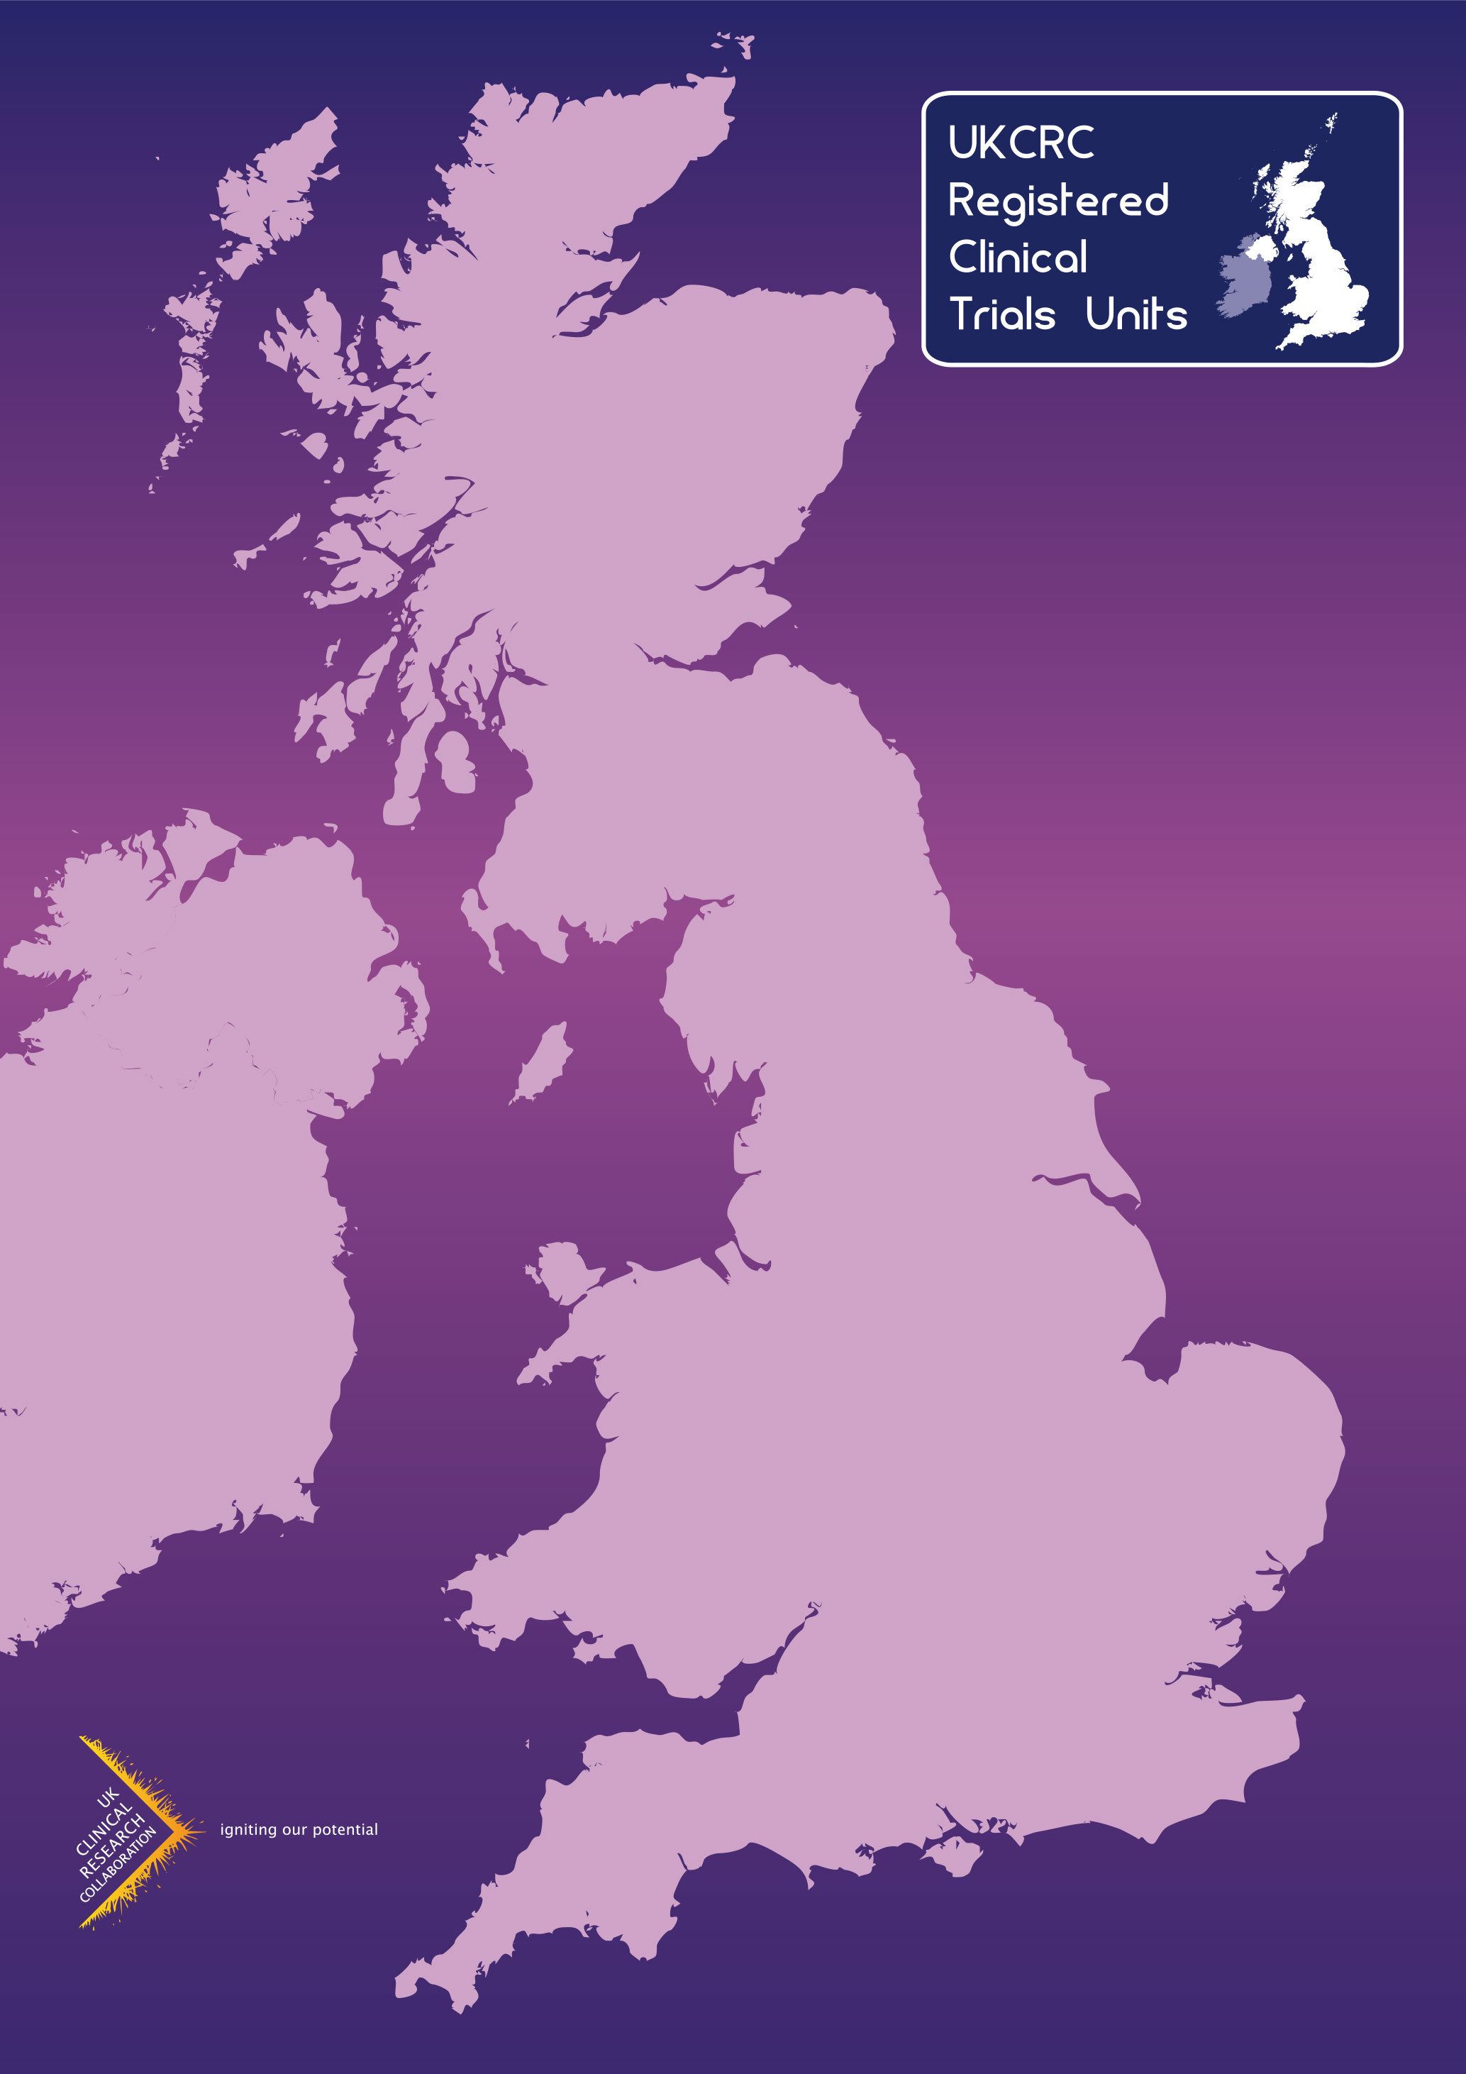
UKCRC Registered CTUs Network
Key Competencies and Evaluation Criteria
Renewal Applications
2021

Appendix 1

Key Competencies for Existing UKCRC Registered Clinical Trials Units

The following competencies should exist in Clinical Trials Units (CTUs), responsible for the design, conduct and analysis of trials or other well-designed studies* (referred to collectively in this document as studies). Clinical Trials Units in this context are defined as a single unit or as a merger or collaborative group (i.e. it is not necessary for all of the expertise required to exist in the same geographical location) fulfilling all key competencies.

Key Competencies

1. Expertise, Continuity and Stability
a) Knowledge, experience and a track record of coordinating (NIHR CRN Portfolio eligible) multi-centre clinical research trials (phase II – IV) or other well designed studies* from design and initiation to publication in peer reviewed journals, with good multi-disciplinary working relationships with investigators, clinicians, academics and experts from other specialties.
b) An established multi-disciplinary team of experienced staff including statisticians, trial/project managers and IT staff. Collaborative groups or merged unit will need to explain/define how the multi-disciplinary team has been established, managed and monitored and in addition, to set out a formal approach to reviewing the individual core disciplines being provided from a different location, prior to the start of any project, to ensure quality from the outset.
c) Demonstration of robust leadership and strategic planning.

2. Infrastructure
a) Resources to provide adequate and stable infrastructure and senior staff as well as an ability to ensure continuity of the core disciplines.
b) Adequate infrastructure to support trials activity with a documented commitment to the Clinical Trials Unit from the host institution.
c) Systems and processes in place for continuing professional development, including Good Clinical Practice (GCP) training for all relevant staff.

3. Quality
a) Systems and processes in place to ensure that staff work to appropriate guidelines and standards.
b) Systems and processes in place to meet appropriate regulations and legislation (e.g. the principles of GCP,UK Policy Framework for Health and Social Care Research, the Data Protection Act and any other UK regulations and legislation relating to Clinical Trials ).
c) Systems and processes in place for risk assessment to guide appropriate monitoring of the whole study process, centrally and at clinical sites.
d) Systems and processes in place to archive study data at the end of a study and to retrieve it subsequently.

4. Information Systems

a) Robust and secure information systems.
b) Access to a secure randomisation system, as appropriate.
c) Evidence of satisfactory validation process.
d) Evidence of adequate staffing to support Information system(s).

5. Publications

a) Evidence of a strong track record of publications in a peer reviewed journal within the last 5 years.

Appendix 2

Evaluation Criteria for UKCRC Registration of Clinical Trials Units

Expertise, Continuity and Stability
Competency | Evaluation Criteria for Full Registration
Knowledge, experience and a track record of coordinating multi-centre clinical research studies from design and initiation to publication in peer reviewed journals, with good multi-disciplinary working relationships with investigators, clinicians, academics and experts from other specialities. | 1.1 Five open to recruitment/in follow-up/in analysis (at least two open) multi-centre randomised controlled trials (phase II-IV) or other well-designed studies, of which at least one has been funded by open national competition with full peer-review and at least one must be a randomised controlled trial (RCT).  1.2 Evidence of being involved in the design, conduct and analysis of the unit’s studies.  1.3 At least three peer reviewed trial publications from the Clinical Trials Unit (CTU) of a recent existing/closed study within the last 5 years. (Can be protocol publications from different studies but must include one final analysis). See item 1.16 for further details.
An established multi-disciplinary team of experienced staff including statisticians, trial/project managers and IT staff. | 1.4 At least two statisticians (with one that has at least five years’ relevant experience), at least two trial/project managers (one with at least five years’ relevant experience) and an appropriate level (for internally hosted systems, this would usually be at least two persons, for externally hosted systems this would usually be a minimum of one person) of IT/IS persons (with at least three years’ experience), ideally all funded independently of specific research grants.  1.5 Collaborative groups will need to explain/define how the multi-disciplinary team will be established, managed and monitored and set out a formal approach to reviewing the individual core disciplines being provided from a different location, prior to the start of any project, to ensure quality from the outset.

Infrastructure
Competency | Evaluation Criteria for Full Registration
Resources to provide adequate and stable infrastructure and senior staff as well as an ability to ensure continuity of the core disciplines.  Adequate infrastructure, to support trials activity with a documented commitment to the Clinical Trials Unit from the host institution and clinical input at the strategic as well as the project level.  Robust leadership and strategic planning | 1.6 Evidence of core funding or of a rolling programme of grants. Evidence of commitment from the host institution.  1.7 Evidence of capacity in terms of staffing, time and expertise to manage unexpected/unplanned circumstances (e.g. personnel changes or trial problems).  1.8 Evidence of clinical input at strategic level  1.9 Evidence of robust research, operational and succession planning strategies.

Quality Assurance
Competency | Evaluation Criteria for Full Registration
Systems and processes in place to meet appropriate regulations and legislation (e.g. the principles of GCP, the UK Policy Framework for Health and Social Care Research , the Data Protection Act and any other UK regulations and legislation relating to Clinical Trials). | 1.10 List of Standard Operating Procedures (SOPs) with version numbers and dates. SOPs in areas identified by the UKCRC-Registered CTUs (see page 5) and evidence of how it is ensured that staff follow SOPs and who is responsible for managing SOPs.
Systems and processes in place for risk assessment to guide appropriate monitoring of the whole study process centrally and at clinical sites. | 1.11 Evidence of a functional system for risk assessment.

Information Systems
Competency | Evaluation criteria for Full Registration
Robust and secure information systems. | 1.12 Evidence of an appropriate data management system.
Evidence of satisfactory validation process | 1.13 Evidence of robust validation process for trial specific database systems and treatment allocation systems.
Access to systems and processes to manage a secure randomisation system. | 1.14 Evidence of systems and processes to manage a secure randomisation system when running RCTs and need to specify system used.
Evidence of adequate staffing to support Information system(s). | 1.15 Evidence that the numbers and experience of systems staff are sufficient to support information system development, management, and validation’

Publications
Competency | Evaluation criteria for Full Registration
Evidence of a strong track record of publications in a peer reviewed journal | 1.16 Three significant peer-reviewed publications of recent existing/closed studies. Publications must fall within your most recent period of registration and must be from separate clinical trials or other well-designed studies that best demonstrate your unit's activity. Ideally, all three should be primary or secondary analyses of recent/existing clinical trials. However, published protocols from different studies do qualify for inclusion. One publication must be a final analysis of a randomised controlled trial (RCT).

Essential areas to be covered by SOPs:

Quality Management Systems
1. Quality Management Systems
2. SOP on SOPs
3. Training

All Trials
4. Sponsorship, contracts/agreements and indemnity
5. Protocol development
6. Statistics
7. Ethical Approvals
8. Regulatory approvals
9. Site set up
- Patient Information
- Registration/Randomisation (if running randomised trials)
- Data management
- Data Sharing
- Monitoring and Independent oversight
- Trial Master File/Site File (Investigator & Pharmacy)
- IT/database
- Trial closure
- End of trial reporting and publication
- Archiving
- Deviations, Misconduct and serious breaches of GCP and/or the Protocol
- Data protection and confidentiality
- Document control
- Trials supplies
- Safety Reporting/Pharmacovigilance
- Urgent safety measures

The term Clinical Trials Unit has been used in this document but experience of leading the design, the central/national coordination and the overall analysis of other clinical research studies; especially large multi-centre epidemiological studies as well as Randomised Controlled Trials will be taken into consideration.
NIHR and Devolved Nations Portfolio eligibility see http://www.crn.nihr.ac.uk/can-help/funders-academics/nihrcrn-portfolio/which-studies-are-eligible-for-clinical-research-network-support/ (NIHR) http://www.cso.scot.nhs.uk/wp-content/uploads/Scottish-studies-and-the-UKCRN-Portfolio.pdf (Scotland) https://www.healthandcareresearch.gov.wales/get-your-study-on-the-clinical-research-portfolio/ (Wales) http://www.nicrn.hscni.net/nicrn-study-adoption/nicrn-adoption-process/ (Northern Ireland) * Must run one Randomised Controlled Trial (RCT)
As judged by NIHR and Devolved Nations Portfolio eligibility.

